TITLE OF THE PAPER (Times New Roman 16 Bold, line spacing 1 pct., capital letters, centered, two blank lines below the header of the page)

Author’s name and academic title (Times New Roman 14 Bold, one line below the Title of the Paper)

Institution / Department/ University/ Town/ Country (Times
New Roman 12 centered, line spacing 1 pct., one line below Author’s name and academic title)

Abstract: (Times New Roman 10 Bold, two rows below the Institution)
Body of abstract (Times New Roman 10). This is a sample of the format of your full paper. Use Word for Windows (Microsoft). Tab (1,2 cm) from the left, line spacing 1.5 pct., two rows below Institution /Department/ University/Town/Country; the abstract text will be normal, justify, line spacing 1,5 pct., size 12 (100-120 words). Use 12pt, Times New Roman. For the words Abstract use bold, 10pt, Times New Roman., for Key-Words use Italics, 10pt, Times New Roman and for References use bold, 14pt, Times New Roman. Bibliographical references will be made between square brackets [1]. They will be included at the end of the paper, use 12pt, Times New Roman.

Key words: 6 to 9 words. Italics, Times New Roman 10, justify, line spacing 1. Leave one line below the abstract and two blank lines between the key words and the introduction.

- Introduction (Times New Roman 14 Bold)
The paper will be edited in English using Times New Roman 12, Justify, line spacing 1p. The paper shall be written using Page setup A4, orientation „Portrait”, „Mirror”. As you can see, for the title of the paper you must use 16pt, Centered, Bold, Times New Roman. Leave two blank lines and then type Author's Name and Academic Title (14pt Times New Roman, centered), Institution /Department/ University/ Town/ Country (in 14pt Times New Roman, centered).

- Chapter name (Times New Roman 14 Bold)
Paragraphs will begin at a distance of 1 Tab (1,2 cm) from the left margin; The heading of each section should be printed in small, 16pt, left justified, bold, Times New Roman. You must use numbers 1, 2, 3, … for the sections' numbering and not Latin numbering (I, II, III, …);
Figures will be numbered as follows:
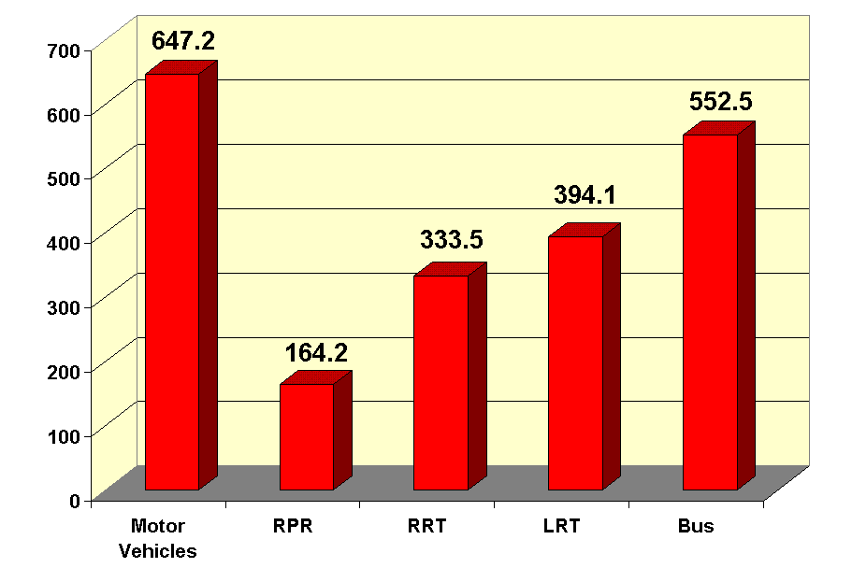
Fig.1 (12pt, Times New Roman, centered, normal)
Tables will be numbered as follows:

Evolution ... | Year | Change %
Table 1 (bold, 12pt, Times New Roman)

2.1 Subsection name
When including a subsection you must use, for its heading, small letters, 12pt, left justified, bold, Times New Roman as here. Please, leave one blank line between successive sections as here.

- Conclusion (Times New Roman 14 Bold)
Please, follow our instructions faithfully, otherwise you have to resubmit your full paper. This will enable us to maintain uniformity in the conference proceedings. Thank you for your cooperation and contribution. We are looking forward to seeing you at the Conference.

References: (Times New Roman 14 Bold)
[1] Authors, Title (Italic), publishing house, year, pages, 12pt Times new Roman, two blank lines below Conclusions.

